Neural Networks & Deep Learning: ICP1

Mallika Mamidi (700746126)

Github Link:

Import the CSV File from google drive

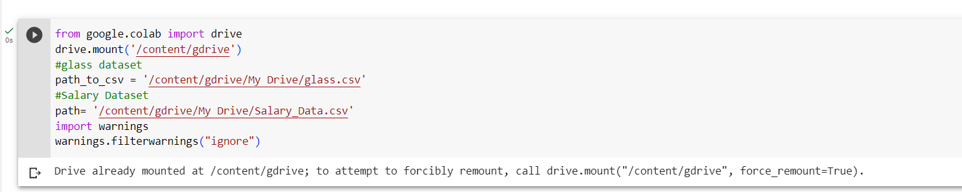

Read the provided CSV file ‘glass.csv’.

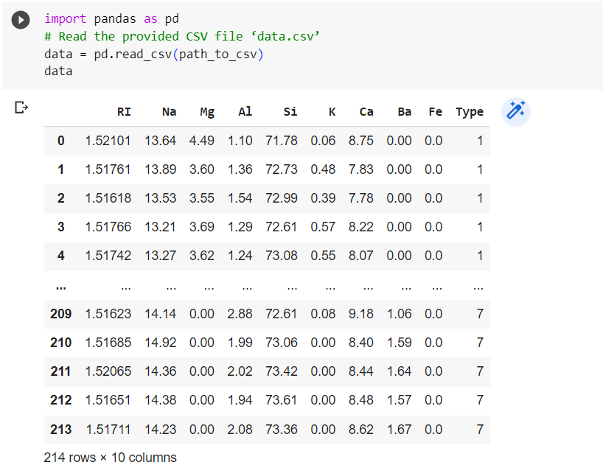

Import libraries for Naive Bayes and SVM algorithm and Split the dataset into training and Testing

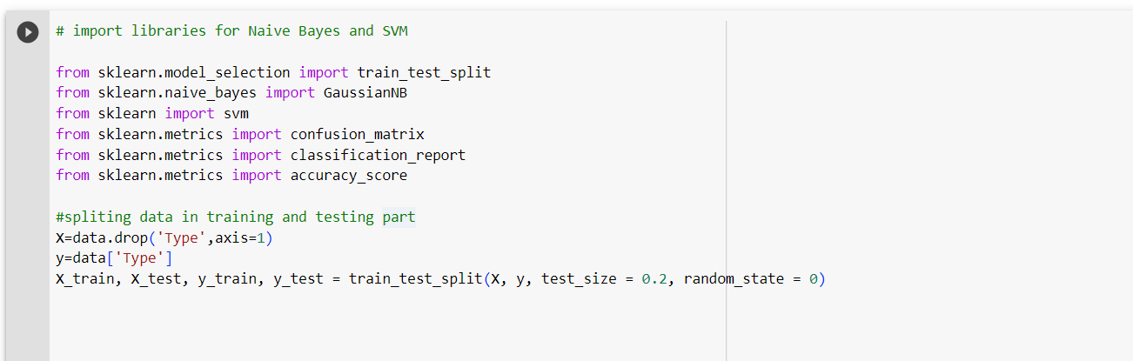

Implement Naïve Bayes method using scikit-learn library

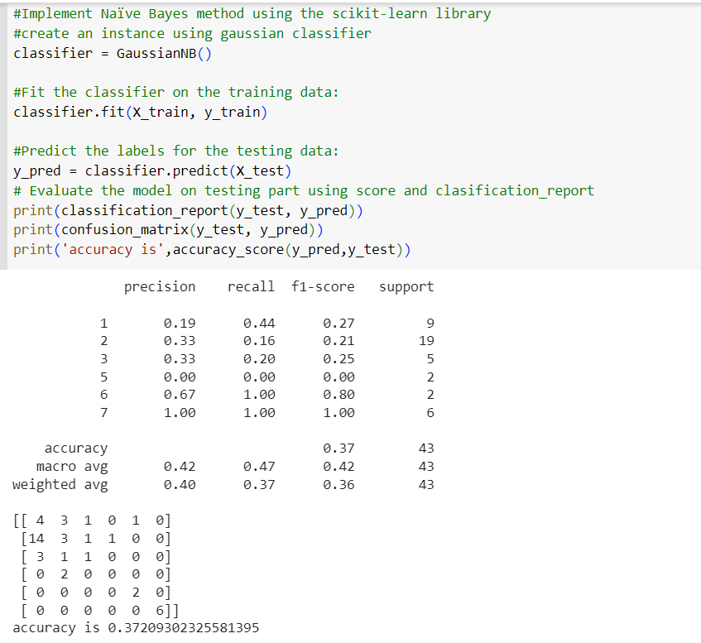

Implement linear SVM method using scikit-learn

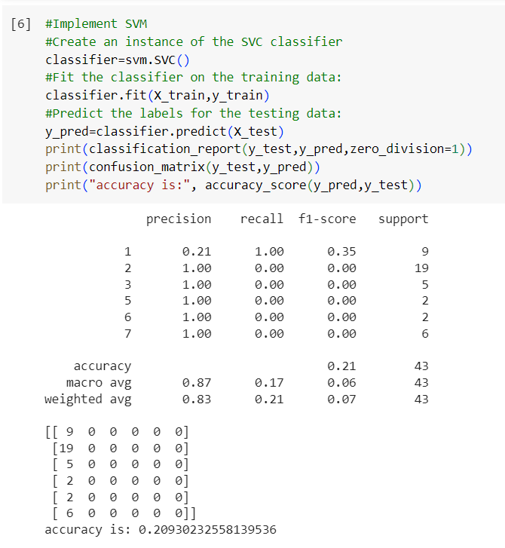

Which algorithm got better accuracy? Can you justify why?

With a better accuracy of 0.3721 compared to 0.2093, Naive Bayes outperformed SVM in accuracy. With a weighted average precision of 0.40, recall of 0.37, and F1-score of 0.36, Naive Bayes had greater accuracy in these three areas. Although SVM had a greater precision, its use could be misleading because of data imbalances. The recall of naive Bayes was low, and it missed a large proportion of positive samples. Accuracy, precision, recall, and F1-score were all areas where Naive Bayes outperformed SVM.

Implement Linear Regression using scikit-learn

a) Import the given “Salary_Data.csv”

b) Split the data in train_test partitions, such that 1/3 of the data is reserved as test subset.

c) Train and predict the model.

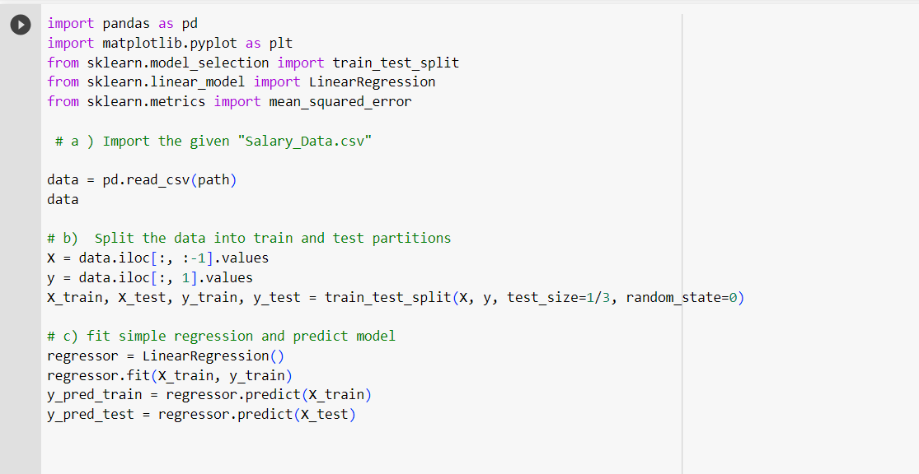

d) Calculate the mean_squared error.

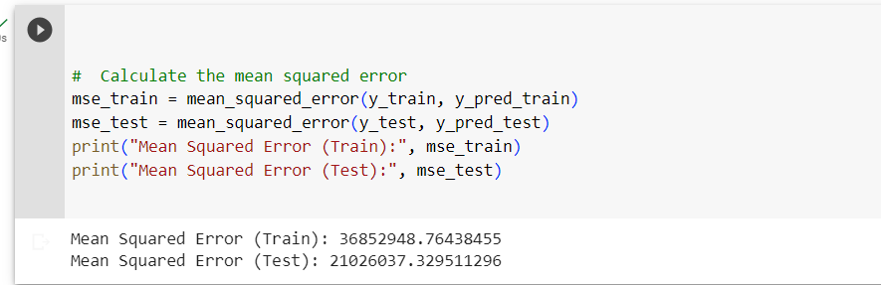

e) Visualize both train and test data using scatter plot.

